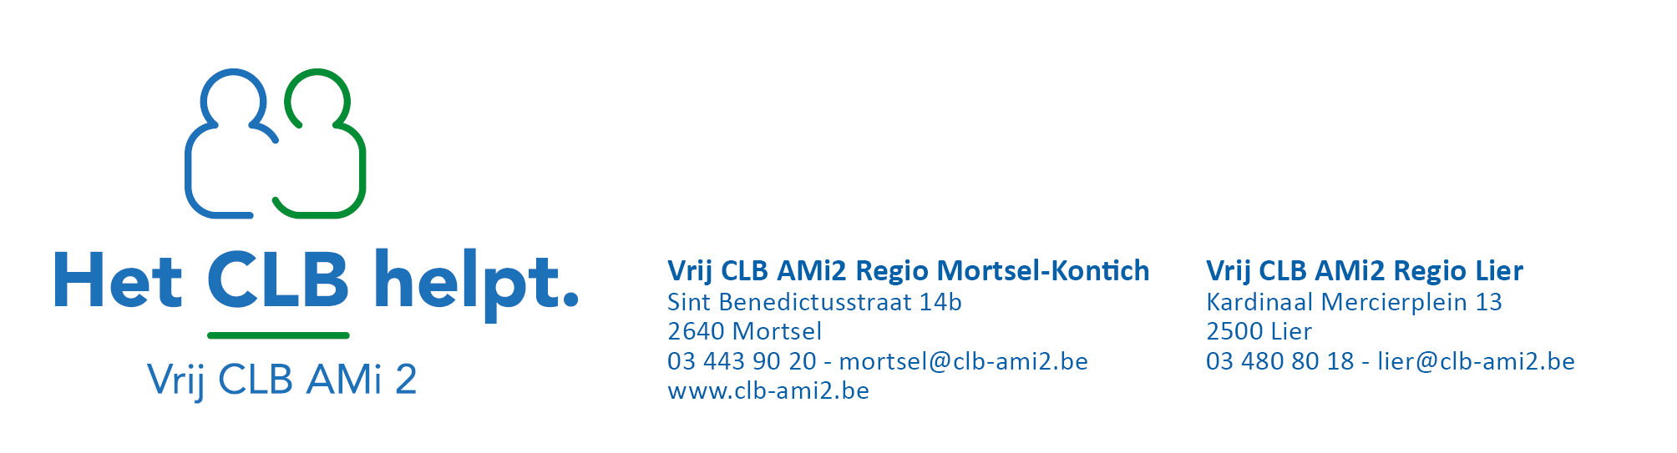

You had contact with someone who has corona at school.
The risk of infection is high.

General information
- You can get sick up to 14 days after you had contact with the person who is infected with corona. Most people who become ill develop complaints within 10 days after contact.

- The risk of being infected depends on the age of the person who is infected corona and the type of contact.

- The CLB (Center for Student Guidance) asks in-depth questions from the (parent of the) person who has corona and from the school. With this information, the CLB will decide whether there was a contact with a low risk or a high risk of infection.

After contacts with a low risk of infection | stay vigilant for 14 days
After contacts with a high risk of infection | 10 days of quarantine | + stay vigilant for 4 days

The risk of infection is high. There is no need to worry, but be extra careful until …/…
What do you* need to do?
*you = the pupil or adult who had contact with someone who was infected with corona at school
- Limit your social contacts  Quarantine up to and including …/…  - Stay at home! Even if you do not feel sick. You may develop complaints later. You can also infect others during that period even if you do not have complaints.  - Only leave your house when this is really necessary, for example to go to the doctor. Then always wear a face mask, unless you are under 12 years old.  - Do not allow visitors in your home.  - As long as you do not get sick, those living in your house do not have to be quarantined.  If you do not feel sick, you can go back to school from …/…  - You do have to limit other contacts. So suspend your hobbies and visits to family or friends up to and including …/… | 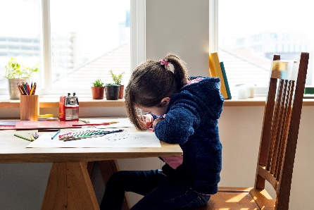
- Monitor your health closely
- Take your temperature twice a day.
- Do you have a cold, a fever, have trouble breathing, cough often or is your sense of smell and taste impaired?
Call your doctor. Your doctor will decide whether a test is necessary and will give you advice.
- Does the doctor decide to do the test and does the test show that you have corona? Then notify the school or the CLB. This allows the CLB to quickly decide whether additional measures are necessary at school.
- Protect those living in your house  - Wash your hands with soap and water. Do so several times a day,  - Cough and sneeze into a paper handkerchief. Throw the handkerchief in the garbage immediately. Then wash your hands.  You don't have a handkerchief? Then cough and sneeze into the crease of your elbow.  - Use separate items at home: eating and drinking utensils (cutlery, glasses, etc.), toothbrushes and towels.  - Ventilate the house well. Open a window or door regularly.  - Avoid contact with vulnerable people living in your house. This includes people who are elderly, have diabetes, heart or lung problems or weaker immune systems. | 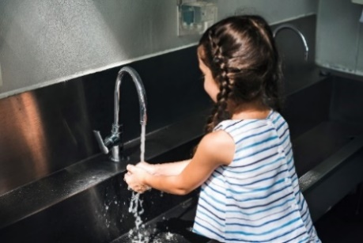  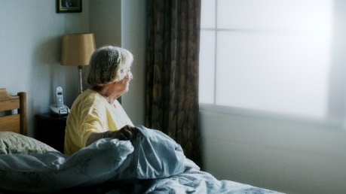

Contact details of the CLB

This document is based on the Sciensano guidelines. VWVJ, 21-10-2020

